Demography and population projection

# Objectives

* Understand the use of projection matrices and the importance of age structure
* Translate a life cycle graph to a projection matrix
* Relate population pyramids to past and future growth of populations
* Understand the main determinants of growth rates

# Before the lab

Review the lecture material and the reading on population growth

Read the informational passages below

Watch the video on population projection on Canvas

Review matrix multiplication, if needed

Take the pre-lab quiz

# Introduction

A **deme** is a population, so demography is the study of populations, but with an emphasis on their changes through time (**dynamics**) and the factors affecting those changes. Although it is easy to come up with simple models that project future population sizes based only on the current number of individuals and a reproductive rate (which may depend on the density), we will focus here on models that include **age structure**.

In these models, the survival and reproductive rates vary with the age or life stage of the organism. This structure can have important consequences for the pace of population growth. For example, if most of the population is in the juvenile stage, future growth may be rapid, but current growth will be slower than for a population that has most individuals in a mature, reproductive stage.

Thus we divide the population into **compartments**, which may be years of age, or stages (newborn, juvenile, pre-reproductive, mature, post-reproductive) in which the rate parameters (survival, reproduction) are all the same (homogeneous).

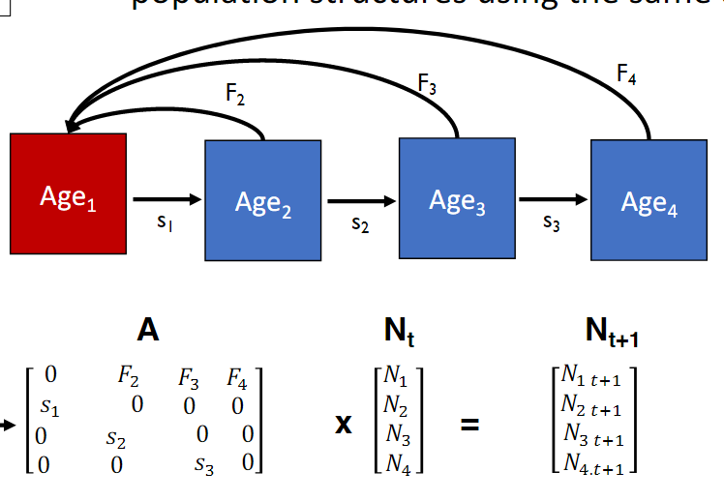

Figure : Age structured model. The life cycle graph is at top. Each age class *x* has a survival rate (*sx*) and a reproductive rate (*Fx*). To predict growth, these are placed in an *x* x *x* projection matrix (*A*) which will be multiplied by the vector of *x* age class sizes (*Nx*, *t*).

Data on age-specific survival and growth rates are typically presented as a **life table** (which can be turned into a matrix, as we shall see). For each age group *x*, the life table lists the fraction surviving (*lx*), the average number of offspring born to a female in that age group (*mx*) and usually the product of these: *lxmx*. The *lx* value is usually calculated from the observed numbers of individuals of each age class (*Sx*), so *lx* =*Sx/S0*.

Table 1 A life table

|  |  |  |  |  |
| --- | --- | --- | --- | --- |
| *x* | *Sx* | *lx* | *mx* | *lx mx* |
| 0 | 500 | 1.0 | 0 | 0 |
| 1 | 400 | 0.8 | 2 | 1.6 |
| 2 | 200 | 0.4 | 3 | 1.2 |
| 3 | 50 | 0.1 | 1 | 0.1 |
| 4 | 0 | 0 | 0 | 0 |
| *R0 =S lx mx* | | | | 2.9 offspring | |

The sum of the *lx mx* values is the net reproductive rate of the population, *R0*. If *R0* > 1.0 the population will increase, and if *R0* < 1.0 the population will decrease.

**Q. 1.1** Explain why both *lx* and *mx* are needed to give the number of offspring of the population.

# Calculating the R0 in R: Squirrels

To do this in R, the *lx* and *mx* values are read into separate vectors of the same length. You will multiply the elements of these two vectors to yield a vector of *lxmx* values. The sum function in R will sum the elements of a vector, so you will use that to calculate the *R0* value of a squirrel population.

Start RStudio. Find the script “squirrels.R” in the folder on the desktop of the lab computer or download it from Canvas (right click the file name on a PC, control-click on a Mac, and save it to a place where you can find it). Load the script. **Do not run it yet – you need to change a couple of things – read on!**

Let’s calculate *R0* for this squirrel population using R. The table (11.1) is from the reading.

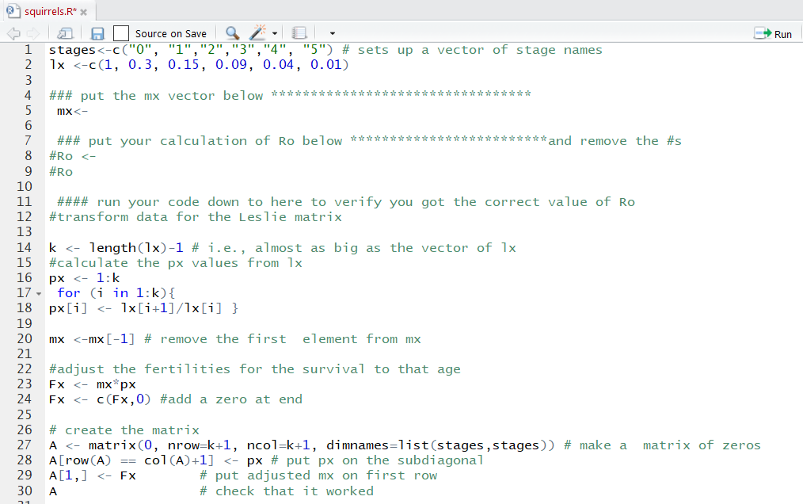



Add here

Add here



Figure 2 First part of Squirrels.R code

The *lx* vector is shown below. It is in the file “squirrels.R” already (line 2).

Lx <-c(1, 0.3, 0.15, 0.09, 0.04, 0.01)

Write the vector for mx using the data in Table 11.1. Add that to the code in line 5.

**Q 1.2.** Figure out the expression for *R0 =S lx mx* in R ________________. Insert this expression on line 8 of the code, and as the answer to Question 1.2 on Gradescope.

Run your code **down to line 10** to verify that you got the value shown above in Table 11.1.

# Projection matrices

**Projection or transition matrices** are used to predict the future population size, as seen in Fig.1. A more general version is shown below. This version allows individuals to remain in a stage with *Px*; in Fig. 1, individuals must either die or progress to the next stage in a time interval.

For a species with 5 age classes (stages) we have a 5x5 transition matrix, and a 5-stage initial vector:

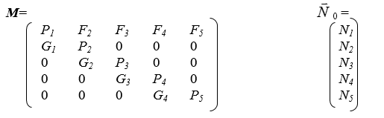

*Gx*= proportion surviving and moving from stage *x* to stage *x+1* in a time interval

*Px* = proportion remaining in stage *x* in a time interval

*Fx* = fecundity (offspring) produced in stage *x* and surviving to enter stage 1

*Nx* = Number in stage *x* (so *SNx = N* total)

If the time interval and the stage classes are the same duration, then all of the *Pi* values will be zero, since all individuals will age out of one stage class and into the next as in Figure 1). For short-lived species the stage classes may be annual and the time interval one year. For humans, the age-classes are often five years and the projections may also be at five-year intervals. For other species there are stages of varying durations and types (e. g. newborn, juvenile, sub-adult, adult, adult non-reproductive). In this age-based transition matrix (above) the sub- & super-diagonals are zero because organisms do not skip over stages, nor do they get younger over time. If it is stage-based, individuals may transition in and out of a reproductive stage.

*Optional self-check 1a. What do the sx values in Fig.1 correspond to in the more general formulation?*

*1b: What fraction of individuals will remain in stage 2 in Fig. 3 below?*

Given the projection matrix and a starting population vector, we can then predict the population size in the next time interval as: 

For example, in a species with only 3 age classes, and using letters in place of numbers:

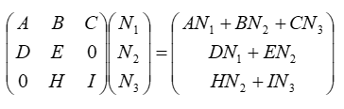

The total population size is of course N1 + N2 + N3 .

Here’s what happens over time, starting from 50 newborns:

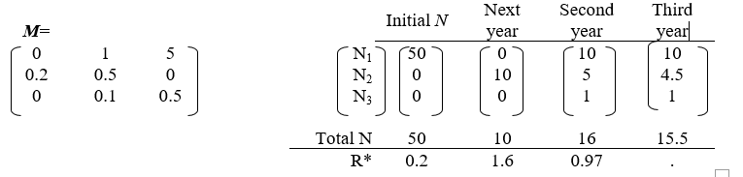

Figure A simple projection.

*  , the rate of change, a value we will examine in more detail below.

Of the 50 initial individuals 50*0.2=10 survive to the next year and grow into the second age class (N2).

These ten give birth to a total of ten offspring that enter class N1 in the second year. Five of these ten (10 * 0.5) survive and stay in N2; and one of the ten (10*0.1) ages into N3. In the next time interval, the five individuals in N2 and the single individual in N3 produce a total of ten offspring that enter N1 in the third year. Two of the previous year’s offspring survive into N2 (10*0.2), and two and a half remain in the stage (5 * 0.5). Half an individual (5 * 0.1) grows into N3, and half an individual (1*0.5) remains in N3. You might be troubled by the idea of fractional individuals, but the elements of a population matrix often represent densities (e.g., individuals per unit area) rather than numbers of individuals, so it’s not as ridiculous as it sounds.

*Optional self-check 2: What is the value of N in the fourth year for Fig. 3?*

#### Properties of these basic models

With a static matrix, the growth rate will stabilize to a fixed value, λ[1]. Moreover, the age distribution (proportion of all individuals in each age class) will stabilize although the number of individuals will continue to change unless the population size is constant (λ=1), as discussed in the population growth reading.

*Optional self-check 3: What is the age distribution in the fourth year for Fig. 3?*

#### Squirrels projection matrix

The projections can be easily done in R once the matrix is set up. For this exercise, we provide you with most of the code, the goal of which is to convert the information in the life table into the elements of the transition matrix.

Here is what the code does in lines 14-30: First, we calculate the *px* values (the fourth column of the life table 11.1) from the values in the *lx* vector: *px = lx+1 / lx*. These *px* values correspond to the *Gx* in the transition matrix above, since this is an annual matrix in which all surviving squirrels move to the next age class the next year. We then multiply the elements of this *px* vector by the elements of the *mx* vector you entered earlier. This allows us to calculate the reproductive output for each age class. Finally, we compile these values into the matrix A, which has the fecundities (birth rates) in the first row and the *px* values on the sub-diagonal.



Figure 4. Second Part of Squirrels.R code.

Your next task is to enter the initial population vector on line 41 of the script file. In the reading, it was 20 newborns and 10 one-year old squirrels. The other 4 age classes are 0s, but they need to be entered too.

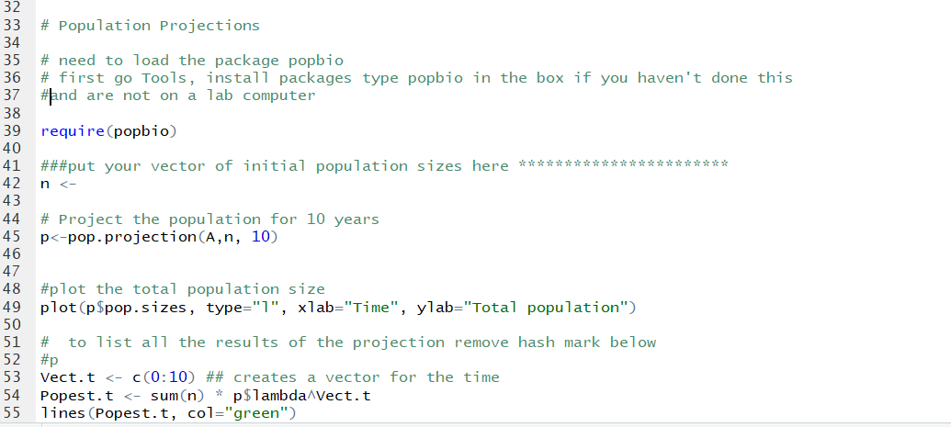

Add here



Figure 5. Third part of Squirrels.R code

We are going to use an R package that is designed to handle projection matrices.

Reminder: To install a package: in R Studio – find the Tools menu and pick “Install Packages.” You then just type the name of the package in the empty box and click the install button.

The package we want is called “popbio” and is based on two books, *Matrix Population Models* (Caswell, 2002) and *Quantitative Conservation Biology* (Morris and Doak, 2002).

Remember, to load the package for a session, you can either use library(popbio) or require(popbio). We have used the latter because it is a little clearer.

The line of code

p<-pop.projection(A, n, 10)

will multiply the matrix **A** by the population vector (starting with **n**), for **10** years to project the population over that time interval. The data frame of results contains many items: the stable age distribution, the size of each age class at each time, the total population size at each time, and the changes in population size from year to year (Nt+1/Nt).

Run the remaining lines of code (11 - end) in squirrels.R. Note the correspondence to the values in your reading.

Note that there are two plots: the total population size vs. time, and the age structure (proportion of the population in each age class) over time.

From here, it is easy to project the population under new assumptions about the fecundity and mortality schedules. For example, imagine that you want to investigate the effects of a habitat change that will lead to new, mostly higher survival probabilities but poorer offspring production. With known the life table changes, you can predict what will happen to the population after the change in habitat. Or if you wish to manage a population, you can rapidly find which management options would best achieve your goals if you know the effects on survival and fecundity.

# The rate of change, R, and λ

Like R0 from the life table, R is useful because it tells us if the population is growing (R>1), shrinking (R<1), or stable (R=1). R is calculated for each time step t as Nt+1 / Nt. In a population with age structure and constant birth and death rates, R fluctuates initially but eventually stabilizes such that the population continues on a trajectory determined by **λ, which is** t**he stable value of R**. We will see that λ can be calculated directly from the matrix, rather than running the projection until the value of R stabilizes.

*Optional self-check 4: what is the value of R between the third and fourth year in Fig 3? Is the population growing or shrinking?*

In the models that we will use, there is no change in the birth and death schedule, there is no density-dependence, and there is no variability due to environment or chance, and thus it would appear that the growth rate should be constant over time. Without considering age structure, a population with a fixed rate of change λ, will grow (or shrink) according to:

(eqn. 1*) Nt = N0λt*

The initial population size is the sum of the elements of vector n,and λ was calculated by the projection function (and is called p$lambda). The following lines of the code do the above calculation.

Vect.t <- c(0:10) ## creates a vector for the time

Popest.t <- sum(n) * p$lambda^Vect.t

By also running the command below, you can compare the growth of the age-structured squirrel population to its growth with no age structure starting from the same total number of squirrels. This command will plot the growth trajectory on the same graph you generated above:

lines(Popest.t, col="green")

So, the black line has age structure, and the green line does not have age structure.

**Q 1.3** Add your names somewhere on the graph of total population vs. time and upload this (as a PNG, BMP, or GIF file) to Gradescope.

**Q 1.4** How do the total population size lines (green and black) compare? Are they identical? If not, describe how they differ.

## Age Structure

The code also plots the proportion in each age class or stage over time, using the function stage.vector.plot. (lines 58-61)

**Q.s 2.1 & 2.2.** What are the relative sizes of the age classes? What happens to them over time?

**Q 2.3.** What happens to the number in each age class in the structured squirrel population over time?

Now we can explore why we should care about age structure.

What if we had a plague that killed all of the young squirrels, so we are left with just older squirrels? Let’s model this scenario.

Make a new initial vector of n with no newborns or 1-year-olds, 4 of age 2, 10 of age 3, 12 of age 4, and 4 of age 5. Note that the initial number of squirrels has not changed.

Re-run the code with this new age structure, adding titles to the graphs that reflect this change, and your names.

**Q 2.4** Explain why the population’s trajectory (black line) is different from the trajectory it would have if there were no age structure (the green line).

# From a life cycle graph to a matrix

Often researchers will present a life cycle diagram showing compartments and transitions. For example, this graph (A) for the endangered Magdalena River Turtle (*Podocnemis lewyana*) from Paez et al., 2015, has eggs & hatchlings (E/H), two juvenile stages, sub-adults and adults. All the stages except the adults transition forward to the next stage each year; adults may remain in their stage for a long time, represented by P5). The corresponding transition matrix is shown in B.

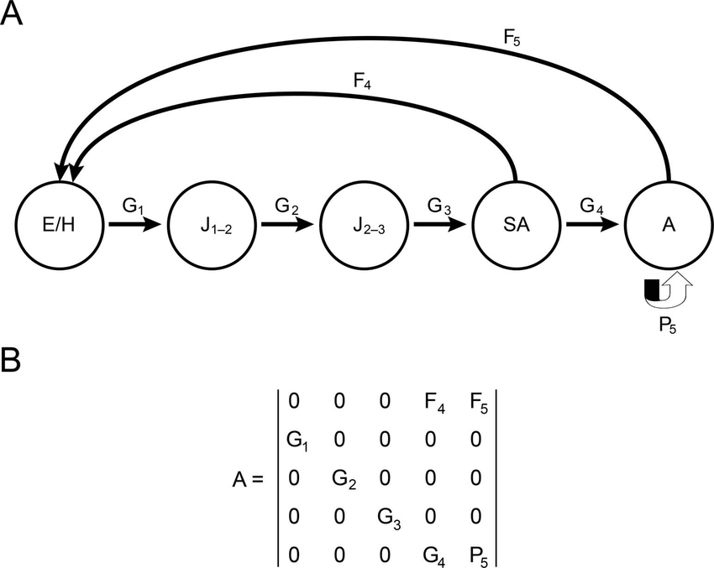

Figure Life cycle graph and transition matrix for Magdalena River turtle.

The black-footed ferret was once thought to be extinct but a small population was discovered, and captive breeding was used to increase their numbers to the point where some could be released back to the wild. How do they fare? 228 were released in Wyoming in 1991-1994 but only 5 were found in 1997 due to outbreaks of plague and canine distemper. However, the population increased after that, and Grenier et al., 2007, measured population parameters for ferrets released in Wyoming. They created the following life cycle diagram:

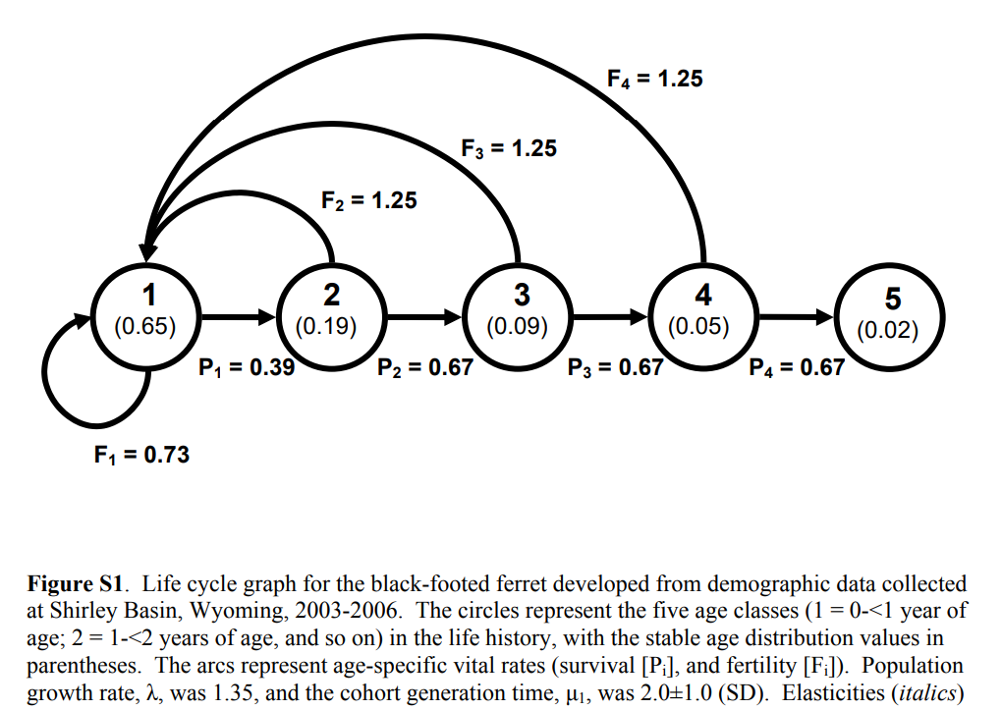

Figure Life cycle diagram for black-footed ferrets. developed from demographic data collected at Shirley Basin, Wyoming, 2003-2006. The circles represent the five age classes (1 = 0-<1 year of age; 2 = 1-<2 years of age, and so on) in the life history. The arcs represent age-specific vital rates (survival [Pi], and fertility [Fi]).

Open the “ferrets.R” script.

Figure out the *px* and *Fx* vector values and fill them in in the code, lines 6 and 8.

**Q 3.1 & 3.2** Run the code and answer the questions on Gradescope.

# Population pyramids

A population pyramid divides a population into age classes for both males and females and thus provides an intuitive visual representation of the age structure of a population. The age structure can transiently affect the population growth rate, as you saw above. The shape of the pyramid is also affected by past growth and mortality events (disease, wars, famines, disasters). Here we will use a simulator that plots both population size and the pyramids. The simulator is at:

<https://www.learner.org/wp-content/interactive/envsci/demographics/demog.html>

The simulator allows you to view pyramids and growth trajectories for nine countries at different stages of demographic transition and with different histories of growth.

We will look at Indonesia, Italy, and Nigeria, which have highly contrasting histories and patterns of growth. Select the country you want to view from the pull-down menu at the top of the simulator page.

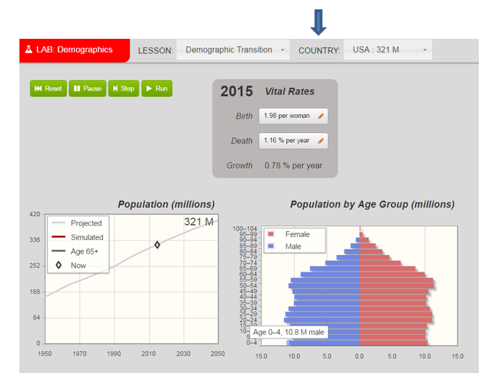

Figure Population simulator with pyramids

**Qs 4.1 -4.3**. Match each country in the list with its population trend by **running the projection to 2100.** Click the green run button twice to project out to the year 2100. See the new line that is generated (ignore the grey line based on UN forecasts).

**Q 4.4**. The pyramid for Italy is widest in the middle. Why is this?

To see how the population pyramids change in the future, you can run the simulation forward in time. Reset then click the green run button twice to project out to the year 2100. Do this for each of the three countries.

**Q.s 4.5-4.7**. What happens to the pyramids of these countries?

# Population momentum

You should note that Nigeria has a very high growth rate. What would happen if we put the brakes on the growth by immediately reducing the births per female to replacement rate fertility (about 2.1 offspring per female)? We can do this by following the instructions below to give Nigeria the birth and death rates of Indonesia.

Reset Nigeria.

Under 2015 *Vital Rates* first click on the box next to “Birth.” Where it says “Use rates from” click the box and choose “Indonesia.” Be sure to click “Apply.”

Repeat for “Death” and apply. Verify that the Birth value is now 2.07 per woman. Run the projection to the year 2100.

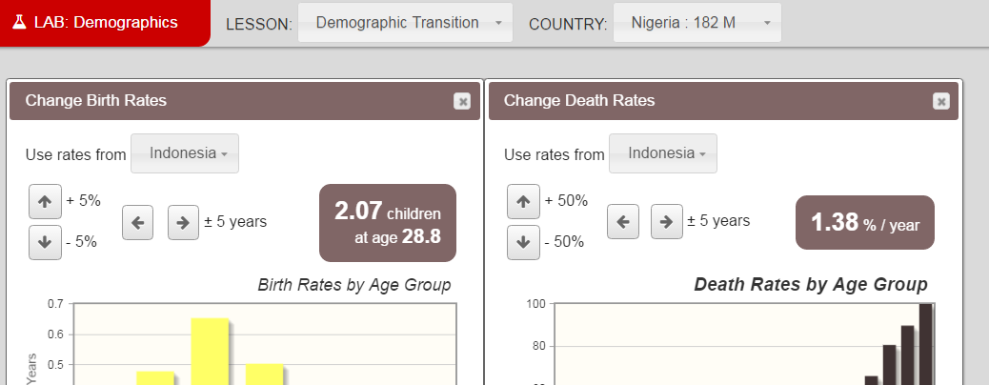



**Q 5.1.** What happens to the population size of Nigeria when you set its growth to the stable value?

As we saw with Nigeria above, and in the Age Structure part of the lab, age structure can lead to temporary states that affect the growth rate. Below is another illustration of the same principle, using the current world population size.



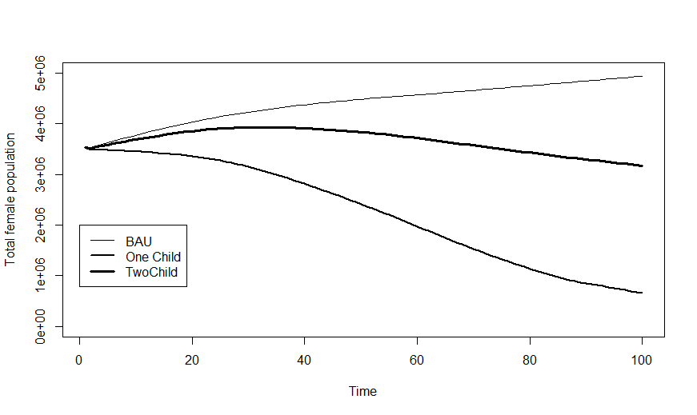

The graph compares “Business as Usual” (BAU), i.e., the growth of the population if it continues at 2015 rates, to the growth if either every couple had two children, starting in 2016, or every couple had only one child.

**Q 5.2.** What is your expectation for the growth of the population if every couple has 2 offspring, all else being equal? How and why does the graph deviate from this expectation?

# Timing of reproduction

In long-lived organisms with multiple potential reproductive episodes like humans, the timing of reproduction can also affect growth rates. We can use the web-based demography simulator to investigate these effects.

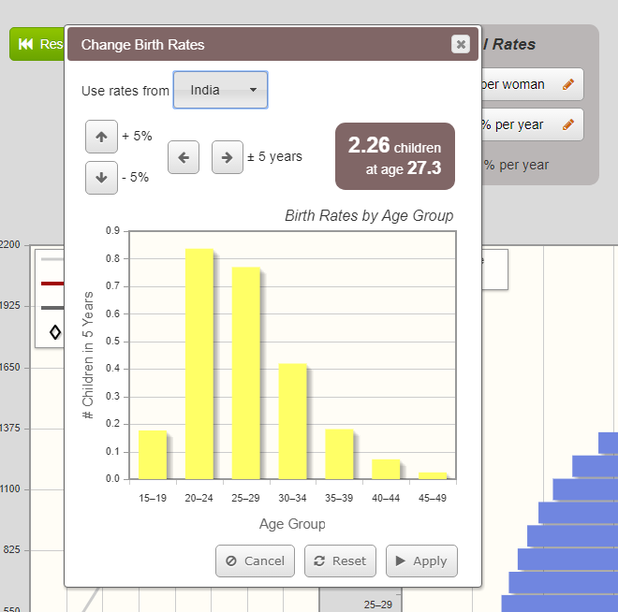  Select India. Record the birth rate, run the projection to 2100, and record the population size as the baseline run in the table below.

Now, we will shift the reproduction 5 years earlier. Click the birth rates box, and then click the left-pointing arrow, which will shift the births 5 years earlier. Click “Apply.”

Record the new birth rate, reset the population and run the simulation through 2100 again.

Now, we will shift 5 years later with a similar series of clicks. First, **be sure to reset the timing of reproduction to the original distribution before you click the right pointing arrow to shift it 5 years later.** Record the birth rate and population size in 2100 below.

|  |  |  |
| --- | --- | --- |
| Run | Birth rate (offspring per female) | Population size in 2100 |
| Baseline | Click or tap here to enter text. | Click or tap here to enter text. |
| 5 years earlier | Click or tap here to enter text. | Click or tap here to enter text. |
| 5 years later | Click or tap here to enter text. | Click or tap here to enter text. |

**Q 6.1** Was there a large shift in the number of offspring per female (greater than 0.2 offspring per female different)?

**Q 6.2** What accounts for the changed growth rate when the births are earlier?

#### Self check answers:

1a. *Gx*.

1b. The fraction remaining in stage 2 is 0.5

2. N4 = 14.7 (you multiply the matrix by the N3 vector, by hand, and sum the elements)

3. 4 = (0.65, 0.29, 0.6) (divide each element of N4 by the total population size)

4. R = N4/ N3 = 0.948. The population is shrinking.

#### References Cited

Caswell, Hal.2001. *Matrix population models*. Sunderland, MA; Sinauer Associates.

M. B. Grenier , D. B. McDonald, and S. W. Buskirk .Rapid Population Growth of a Critically Endangered Carnivore. *Science* **317**,779-779(2007). DOI:[10.1126/science.1144648](https://doi-org.proxy.uchicago.edu/10.1126/science.1144648)

Lutz, W. & Qiang, R. 2002. Determinants of human population growth. Philosophical Transactions of the Royal Society B: Biological Sciences, 357(1425), 1197–1210. http://doi.org/10.1098/rstb.2002.1121

Morris, W. F. & Doak, D.F. 2002. *Quantitative conservation biology: theory and practice of population viability analysis*. Sunderland MA; Sinauer Associates.

Vivian P. Páez, Brian C. Bock, Paula A. Espinal-García, Beatriz H. Rendón-Valencia, Diego Alzate-Estrada, Viviana M. Cartagena-Otálvaro, and Selina S. Heppell "Life History and Demographic Characteristics of the Magdalena River Turtle (*Podocnemis lewyana*): Implications for Management," *Copeia* 103(4), 1058-1074, (1 December 2015). https://doi.org/10.1643/CE-14-191

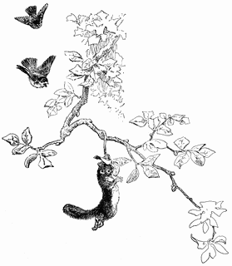

1. As mentioned in lecture, this is the eigenvalue of the matrix, for the mathematically inclined.